CELL CYCLE
By Yogeshwari Tiwari,
Department of Biotechnology
Govt. Digvijay Autonomous P.G. College, Rajnandgaon
INTRODUCTION –
A cell cycle is a series of events that a cell passes through from the time until it reproduces a replica.
It is the growth and division of a single cell into daughter cells and the duplication.
In animals, the whole cell cycle takes around 24hours from start to finish.
Some cells, such as skin cells, are constantly going through the cell cycle.
Nerve cells do not grow and divide; they only mature.
PHASES OF CELL CYCLE
The cell cycle completes in two phases –
1. Interphase (23 hr.) - G1 – Phase, S – Phase, G2 – Phase
2. Division phase (M phase) (1hr.)
Karyokinesis – nuclear division
Cytokinesis – cytoplasmic division
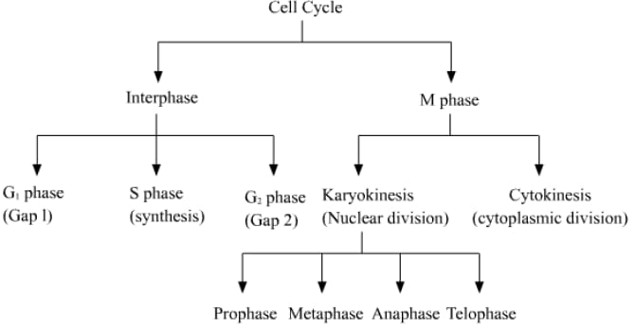

1. Interphase is subdivided into four phases –
G1 -phase – Growth and maturation occur in this phase.
This phase is the longest phase (11) of the cell cycle.
During this phase cell chooses either to replicate its DNA or to exit the cell cycle and enter in quiescent state (G0 phase)
S - phase – DNA synthesis occurs in this phase.
It takes 8 hr. to complete DNA synthesis.
In this phase, cells are present in 2n and 4C conditions.
G2 – phase – In this phase cell prepares for mitosis.
During the gap between DNA synthesis and mitosis, the cell will continue to grow.
In this phase, spindle Fiber and skeletal protein formed
This phase is complete in 4 hr.

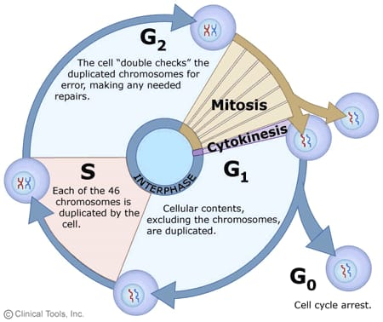
Fig. cell cycle

2. Division phase/M-phase
The division phase is the shortest phase of the cell cycle; and it is completed in 1hour.
In this process cell duplicates its chromosomes and divides its nucleus to form two genetically identical daughter cells.
Process complete in the following steps -
Prophase: Chromosomes condense and become visible; the nuclear envelope starts breaking down, forming the mitotic spindle.
Metaphase: Chromosomes align at the cell's center (metaphase plate).
Anaphase: Sister chromatids separate and are pulled to opposite poles.
Telophase: New nuclear envelopes form around the two sets of chromosomes; chromosomes uncoil.

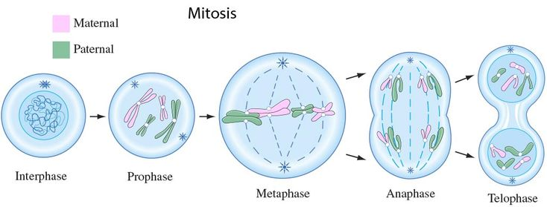

Cytokinesis: The cytoplasm divides, completing the formation of two distinct daughter cells.
In animals, during cytoplasm division cleavage furrow is formed, but in a plant cell plate is formed.
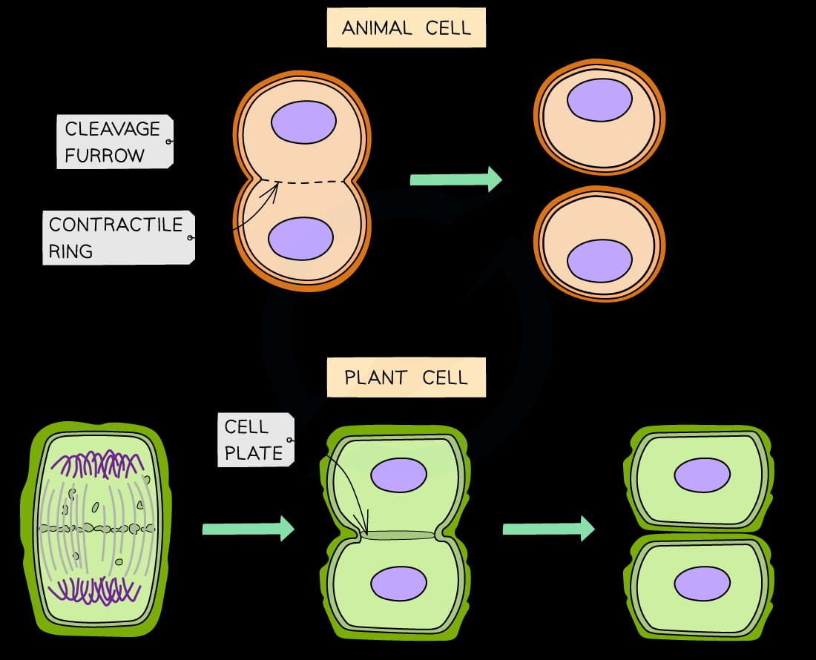

As a result of this cytoplasmic division, two daughter cells are formed from the parental cell.

